МИНИСТЕРСТВО ОБРАЗОВАНИЯ РЕСПУБЛИКИ БЕЛАРУСЬ

УЧРЕЖДЕНИЕ ОБРАЗОВАНИЯ
ГОМЕЛЬСКИЙ ГОСУДАРСТВЕННЫЙ ТЕХНИЧЕСКИЙ УНИВЕРСИТЕТ ИМЕНИ П. О. СУХОГО

Факультет автоматизированных и информационных систем

Кафедра «Информатика»

ОТЧЕТ ПО ЛАБОРАТОРНОЙ РАБОТЕ № 4
по дисциплине «Алгоритмы и структуры данных»

на тему: «Хэширование»

Выполнил: студент гр. ИП-32
Суховенко Э.С.
Принял: преподаватель Процкая М.А.

Гомель 2022
Цель работы: Изучить основы построения хэш-функций и методами разрешения коллизий.
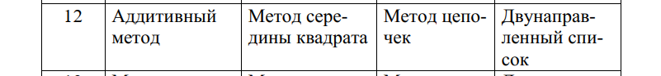
Вариант 12
Код программы:
namespace Lab4_hashing.DList;
public partial class DLinkedList<T>
{
public void Add(T item)
{
Push(item);
}
public void Insert(int index, T value)
{
if (index > Count)
throw new Exception("Out of bound exception, [insert]");
var node = new DNode<T>(value);
if (index == 0)
{
if (Count == 1)
{
node.Next = head;
head!.Prev = node;
}
else if (Count > 1)
{
head!.Prev = node;
node.Next = head;
}
head = node;
}
else if (index == Count)
{
tail!.Next = node;
node.Prev = tail;
}
else
{
var curIndex = 0;
var tempNode = head;
while (curIndex < index - 1 && tempNode?.Next != null)
{
tempNode = tempNode.Next;
curIndex++;
}
node.Next = tempNode?.Next;
node.Prev = tempNode;
tempNode!.Next = node;
node.Next!.Prev = node;
}
if (index == Count)
tail = node;
Count++;
}
public void UnShift(T value)
{
Insert(0, value);
}
public void Push(T value)
{
Insert(Count, value);
}
}
namespace Lab4_hashing.DList;
public partial class DLinkedList<T>
{
public void Clear()
{
while (Count > 0) Pop();
}
}
namespace Lab4_hashing.DList;
public partial class DLinkedList<T>
{
public bool Contains(T item)
{
return Find(x => x!.Equals(item));
}
public bool Find(Func<T, bool> predicate)
{
var tempNode = head;
while (tempNode != null)
{
if (predicate(tempNode.Value))
return true;
tempNode = tempNode.Next;
}
return false;
}
}
using System.Collections;
namespace Lab4_hashing.DList;
public partial class DLinkedList<T>
{
public IEnumerator<T> GetEnumerator()
{
var current = head;
while (current != null)
{
yield return current.Value;
current = current.Next;
}
}
IEnumerator IEnumerable.GetEnumerator()
{
return GetEnumerator();
}
}
namespace Lab4_hashing.DList;
public partial class DLinkedList<T>
{
public void CopyTo(T[] array, int arrayIndex)
{
const string baseErrorMessage = "DLinkedList[IList::CopyTo]";
if (array == null)
throw new Exception($"{baseErrorMessage} Array is null.");
if (arrayIndex < 0)
throw new Exception($"{baseErrorMessage} ArrayIndex is less than zero.");
if (array.Rank > 1)
throw new Exception($"{baseErrorMessage} Array is multidimensional.");
if (array.Length - arrayIndex < Count)
throw new Exception($"{baseErrorMessage} Not enough elements after index in the destination array.");
for (var i = 0; i < Count; ++i)
array.SetValue(this[i], i + arrayIndex);
}
public bool IsReadOnly => false;
}
namespace Lab4_hashing.DList;
public partial class DLinkedList<T>
{
public T this[int index]
{
get
{
if (index >= Count)
throw new Exception("Out of bound exception, [get]");
var curIndex = 0;
var current = head;
while (curIndex < index)
{
current = current!.Next;
curIndex += 1;
}
return current!.Value;
}
set
{
if (index >= Count)
throw new Exception("Out of bound exception, [get]");
var curIndex = 0;
var current = head;
while (curIndex < index)
{
current = current!.Next;
curIndex += 1;
}
current!.Value = value;
}
}
}
namespace Lab4_hashing.DList;
public partial class DLinkedList<T>
{
public int IndexOf(T item)
{
return IndexOf(x => x!.Equals(item));
}
public int IndexOf(Func<T, bool> predicate)
{
var index = 0;
var tempNode = head;
while (tempNode != null)
{
if (predicate(tempNode.Value))
return index;
tempNode = tempNode.Next;
index += 1;
}
return -1;
}
}
namespace Lab4_hashing.DList;
public partial class DLinkedList<T>
{
public void RemoveAt(int index)
{
Erase(index);
}
public bool Remove(T item)
{
var index = IndexOf(item);
if (index != -1)
Erase(index);
return index != -1;
}
public T Shift()
{
return Erase(0);
}
public T Pop()
{
return Erase(Count - 1);
}
public T Erase(int index)
{
if (index >= Count)
throw new Exception("Out of bound exception, [erase]");
T deletedValue;
if (Count == 1)
{
deletedValue = head!.Value;
head = tail = null;
}
else
{
if (index == 0)
{
deletedValue = head!.Value;
head = head!.Next;
head!.Prev = null!;
}
else if (index == Count - 1)
{
deletedValue = tail!.Value;
tail = tail!.Prev;
tail!.Next = null;
}
else
{
var curIndex = 0;
var tempNode = head;
while (curIndex < index - 1 && tempNode?.Next != null)
{
tempNode = tempNode.Next;
curIndex++;
}
deletedValue = tempNode!.Next!.Value;
tempNode!.Next = tempNode.Next!.Next;
tempNode.Next!.Prev = tempNode;
}
}
Count -= 1;
return deletedValue;
}
}
namespace Lab4_hashing.DList;
public partial class DLinkedList<T> : IList<T>
{
private DNode<T>? head;
private DNode<T>? tail;
public DLinkedList()
{
head = tail = null;
Count = 0;
}
public int Count { get; private set; }
}
namespace Lab4_hashing.DList;
public class DNode<T>
{
public DNode(T value)
{
Value = value;
Next = Prev = null;
}
public DNode<T>? Next { get; set; }
public DNode<T>? Prev { get; set; }
public T Value { get; set; }
}
using Lab4_hashing.HsTable;
namespace Lab4_hashing.HashFunctions;
public class Additive
{
public static HashLengthFunc HashFunc = (str, length) => Math.Abs(str.Aggregate(0, (acc, x) => acc + x * 31) % length);
}
using Lab4_hashing.HsTable;
namespace Lab4_hashing.HashFunctions;
public class Middle
{
public static HashLengthFunc HashFunc = (str, length) =>
{
var sum = str.Aggregate(0, (acc, x) => acc + x);
var sq = (sum * sum).ToString();
return int.Parse(sq[..^2]) % length;
};
}
using Lab4_hashing.DList;
namespace Lab4_hashing.HsTable;
public delegate int HashLengthFunc(string s, int length);
public delegate int HashFunc(string s);
public class HashTable
{
private readonly DLinkedList<string>[] _array;
private HashFunc GetHash { get; }
public HashTable(HashLengthFunc hashFunc, int length = 50)
{
_array = new DLinkedList<string>[length];
for (var i = 0; i < _array.Length; i++) {
_array[i] = new DLinkedList<string>();
}
GetHash = s => hashFunc(s, length);
}
public void AddMany(IEnumerable<string> strings) => strings.ToList().ForEach(s => _array[GetHash(s)].Add(s));
public void Delete(string s) => _array[GetHash(s)].Remove(s);
public bool Search(string s) => _array[GetHash(s)].Contains(s);
public void Show()
{
for (var i = 0; i < _array.Length; i++)
Console.Write($"{i} | {_array[i].Aggregate("", (current, s) => current + s + " ")} \n");
Console.WriteLine();
}
}
using Lab4_hashing.DList;
namespace Lab4_hashing;
public class IO
{
public static string[] ReadFile(string path)
{
var words = new DLinkedList<string>();
using (var reader = new StreamReader(path))
{
string line;
while ((line = reader.ReadLine() ?? string.Empty) != "") words.Add(line);
}
return words.ToArray();
}
}
using System.Diagnostics;
using Lab4_hashing.HsTable;
namespace Lab4_hashing;
public class Menu
{
private readonly string _hashName;
private readonly HashTable _hashTable;
private readonly string[] _data;
public Menu(HashTable hashTable, string[] data, string hashName)
{
_hashTable = hashTable;
_data = data;
_hashName = hashName;
}
private static int CalcTicks(Action func)
{
var time = new Stopwatch();
time.Start();
func();
time.Stop();
return (int) time.ElapsedTicks;
}
private static string ReadString() => Console.ReadLine() ?? string.Empty;
private static void PrintTicks(string before, int time, string after = "s\n") =>
Console.WriteLine($"{before} {(double) time / 10000} {after}");
private static void PrintTimeOfAction(string before, Action func, string after = "s\n")
=> PrintTicks(before, CalcTicks(func), after);
public void Run()
{
var time = CalcTicks(() => _hashTable.AddMany(_data));
_hashTable.Show();
PrintTicks($"time add to {_hashName} hashtable:", time);
do
{
Console.WriteLine("1. Remove 2. Search 0. Exit\n");
var choose = int.Parse(ReadString());
switch (choose)
{
case 1:
{
Console.Write("Input string to remove: ");
var elem = ReadString();
time = CalcTicks(() => _hashTable.Delete(elem));
_hashTable.Show();
PrintTicks("\ntime delete element to fnv hashtable:", time);
break;
}
case 2:
{
Console.Write("Input string to search: ");
var elem = ReadString();
time = CalcTicks(() => _hashTable.Search(elem));
_hashTable.Show();
Console.WriteLine(_hashTable.Search(elem) ? "exists" : "does not exist");
PrintTicks("\ntime search element to fnv hashtable: ", time);
break;
}
case 0:
return;
}
} while (true);
}
}
using Lab4_hashing;
using Lab4_hashing.HashFunctions;
using Lab4_hashing.HsTable;
string[] hashTypes = { "Additive", "Middle" };
const string path = "../../../resources/words.txt";
var main = () =>
{
do
{
for (var i = 0; i < hashTypes.Length; ++i)
Console.WriteLine($"{i + 1}. {hashTypes[i]}");
var choose = int.Parse(Console.ReadLine() ?? string.Empty);
var data = IO.ReadFile(path);
var additiveHashTable = new HashTable(Additive.HashFunc);
var middleHashTable = new HashTable(Middle.HashFunc);
var additiveMenu = new Menu(additiveHashTable, data, hashTypes[0]);
var middleMenu = new Menu(middleHashTable, data, hashTypes[1]);
switch (choose)
{
case 1:
additiveMenu.Run();
break;
case 2:
middleMenu.Run();
break;
}
} while (true);
};
main();
// DLinkedList<string> dlist = new();
// string[] arr = {"1", "2", "3", "4", "5", "6", "7", "8", "9", "10"};
// foreach (var x in arr) dlist.Add(x);
// Console.WriteLine(string.Join(", ", dlist.Where(x => x.CompareTo("8") >= 0)).ToList());
// foreach (var x in dlist) Console.WriteLine(x);

Результаты работы программы:
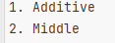
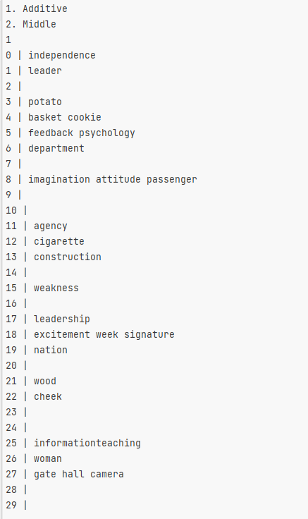
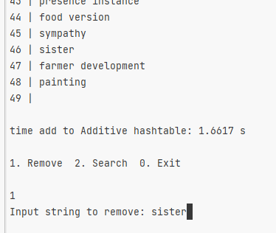

Асимптотическая оценка сложности алгоритма:
O(len(s)) – вычислить хеш для обоих методов.
O(n * avg(len(s))) – построить хеш-таблицу.
O(1) ― поиск/вставка/удаление.
Наилучшую, наихудшую и среднюю оценки:
O(n) ― наихудшая оценка, если хеши всех строк равны и защита от такого не предусмотрена.
Псевдокод операции на упрощённом языке:
public class HashTable
{
private readonly DLinkedList<string>[] _array;
private HashFunc GetHash { get; }
public HashTable(HashLengthFunc hashFunc, int length = 50)
{
_array = new DLinkedList<string>[length];
for (var i = 0; i < _array.Length; i++) {
_array[i] = new DLinkedList<string>();
}
GetHash = s => hashFunc(s, length);
}
public void AddMany(IEnumerable<string> strings) => strings.ToList().ForEach(s => _array[GetHash(s)].Add(s));
public void Delete(string s) => _array[GetHash(s)].Remove(s);
public bool Search(string s) => _array[GetHash(s)].Contains(s);
public void Show()
{
for (var i = 0; i < _array.Length; i++)
Console.Write($"{i} | {_array[i].Aggregate("", (current, s) => current + s + " ")} \n");
Console.WriteLine();
}
}

Вывод: изучил основы построения хэш-функций и методами разрешения коллизий.

